**User Manual**

**V 1.0**

**for the**

**Veteran Appointment Notification System (VANS) Administrator**

*Document Prepared For:*

**Technology Acquisition Center**

**U.S. Department of Veterans Affairs**

**Tridec Technologies, LLC**

**Contract No.**

*Document Date:*

**June 2014**

Table of Contents

Introduction 5

Appointment List 6

Select Patient 6

Viewing Patient Appointments 6

Begin/End Date 7

Appointment Lists 7

Create/Send Appointment Letter 8

Choose Appointment(s) 8

Appointment Details 8

Delete a Letter 10

Letter Preview 10

Information Displayed 10

Print Letter 10

Release/Send Letter 10

Template Management 11

Template List 11

Add/Edit Template 12

Delete Template 13

Search by Clinic 14

Signature Management 16

Signature List 16

Add/Edit Signature 16

Delete a Signature 17

User Information 17

Contact Information 17

Edit Contact Information 18

Account Information 18

Change Password 19

Update Security Question 19

User Management 20

User Accounts 20

Edit User Information 21

Link User to Vista 22

Reset Password 24

View User Access 25

New User 25

Roles 26

Create Role 27

Edit Role 27

View Permissions 28

Delete Role 28

**List of Figures**

Figure 1: Patient Search 6

Figure 2: Appointment Lists 7

Figure 3: Appointment Details 8

Figure 4: Comments and Signature 9

Figure 5: Letter Preview 11

Figure 6: Template List 12

Figure 7: Edit Template 13

Figure 8: Search by Clinic 15

Figure 9: Signature List 16

Figure 10: Add/Edit Signature 17

Figure 11: Contact Information 18

Figure 12: Edit Contact Information 18

Figure 13: Account Information 20

Figure 14: User Accounts 21

Figure 15: Edit User Information 22

Figure 16: Reset Linked User 23

Figure 17: Link to Vista 24

Figure 18: View User Access 25

Figure 19: New User 26

Figure 20: Roles 27

Figure 21: Create Role 27

Figure 22: Edit Role 28

## Introduction

The Veteran Appointment Notification System (VANS) is a web based application that allows VA administrators to create and send notification letters to patients. With this system, patients receive clear and organized letters with all the information they need to successfully attend appointments. This manual is for the VANS Administrator.

## Appointment List

### Select Patient

* Type search criteria into the textbox and click ‘Find’. (Figure 1)
  + Search for patients using the following criteria:
    - Social Security Number
    - Name, in the format ‘LastName,FirstName’
    - Last initial, followed by the last four digits of SSN (e.g. A1234)

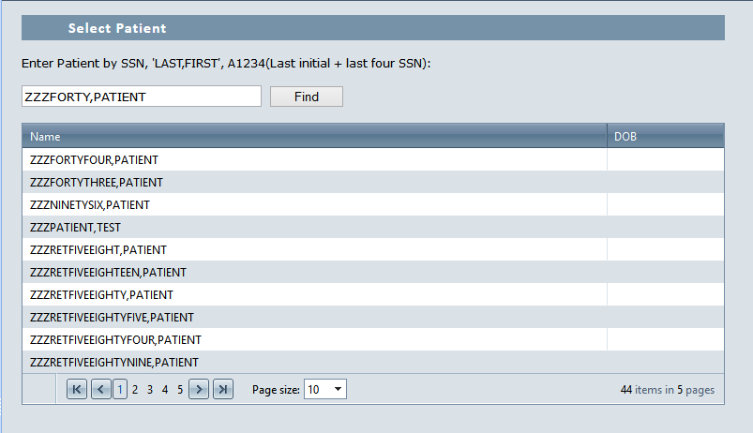

Figure 1: Patient Search

### Viewing Patient Appointments

* Click the Name of the desired patient to view that patient’s scheduled appointments. (Figure 1)
* There are two appointment tables – Patient Appointments without Letters, and Patient Appointments with Letters. (Figure 2)

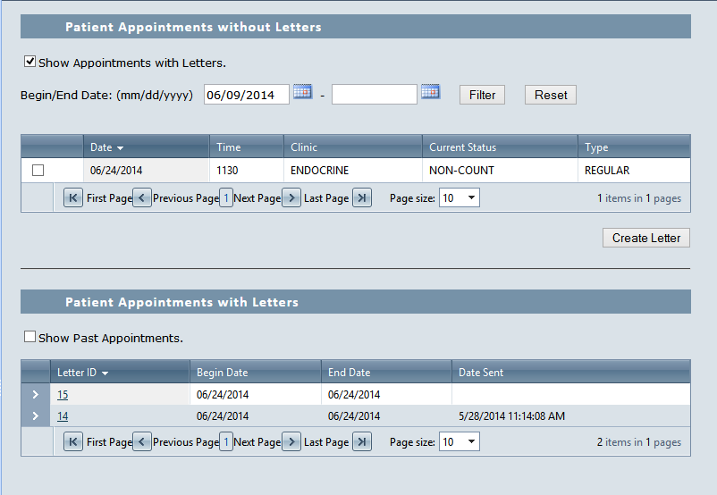

Figure 2: Appointment Lists

### Begin/End Date

* By default, the ‘Appointments without Letters’ table is filtered to only display appointments on current and future dates. (Figure 2)
  + The date filters can be changed by typing new dates, or by clicking the calendar icons beside the Begin/End Date fields and choosing a date on the calendar.
  + The ‘Reset’ button removes the date filters from the table.

### Appointment Lists

* The ‘Show Appointments with Letters’ checkbox toggles whether the ‘Appointments without Letters’ table displays appointments that already have letter groups associated with them. (Figure 2)
* The ‘Show Past Appointments’ checkbox toggles whether the ‘Appointments with Letters’ table shows appointments with a ‘Begin Date’ before the current date. (Figure 2)
* Click the ‘>’ beside an Appointment with Letter to view more information about the appointment nested in the table. (Figure 2)

## Create/Send Appointment Letter

### Choose Appointment(s)

* Click the checkbox next to the desired appointment(s) in the ‘Appointments without Letters’ table then click the ‘Create Letter’ button. (Figure 2)
* A letter group will be added to the “Appointments with Letters”.
* Click the number of a letter group to go to the “Appointment Details” page. (Figure 2)

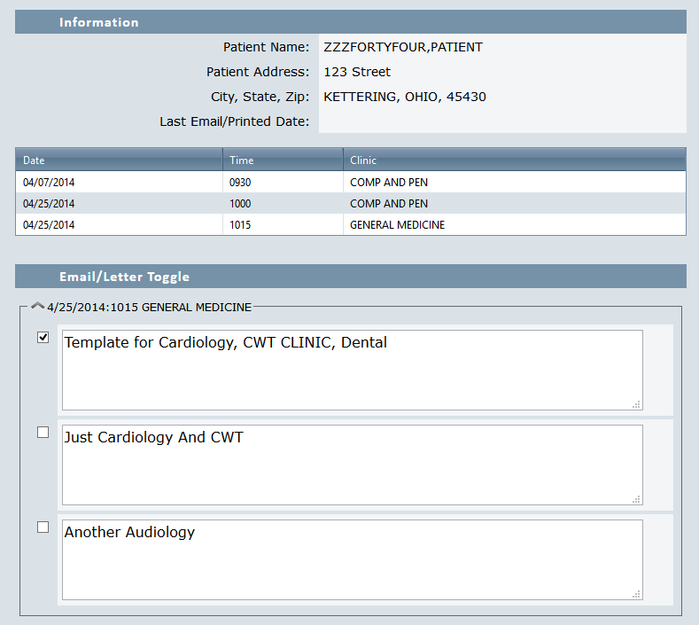

Figure 3: Appointment Details

### Appointment Details

* Click the checkbox next to a template to include it in the appointment letter. (Figure 3)
  + To expand or collapse a clinic’s template list, click the arrow to the left of the clinic’s name.
* Users with the ‘Admin’ role can edit templates for the current letter.
* To add additional information to the letter, type it in the ‘Additional Comments’ field. (Figure 4)
  + Users with the ‘AppointmentUser’ role cannot leave additional comments.
* Select a signature from the ‘Select Signature’ dropdown list, or type a custom signature. (Figure 4)
  + Signatures from the dropdown can be customized for the current letter.
    - The ‘Reset Signature’ button loads the default version of the selected signature.
  + Users with the ‘AppointmentUser’ role cannot edit signatures.
* Click the ‘Save’ button to save changes to the letter, or click the ‘Cancel’ button to close the form without saving. (Figure 4)
* Click the ‘Preview’ button to view a preview of the letter. (Figure 4)

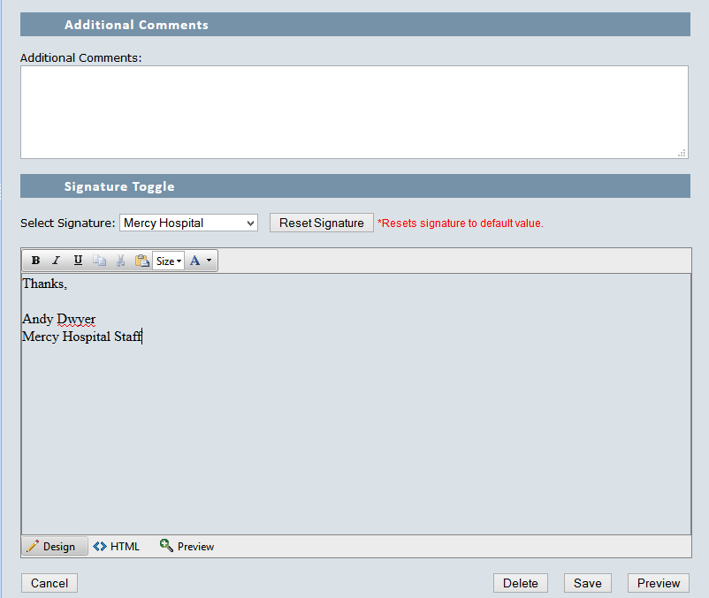

Figure 4: Comments and Signature

### Delete a Letter

* Click the ‘Delete’ button to delete a letter. (Figure 4)
  + A letter cannot be deleted after it has been released to the patient.

## Letter Preview

### Information Displayed

* All selected information is displayed in read-only form in the preview: (Figure 5)
  + Patient Information
  + Appointment schedule
  + Selected clinics and templates
  + Additional Comments
  + Signature
* Click the ‘Back’ link to return to the Appointment Details page.

### Print Letter

* Click the ‘Print’ link at the top of the page to print the letter. (Figure 5)
  + The letter will be released to the patient, who will be able to access it using their account on the site.

### Release/Send Letter

* Click the ‘Release/Email’ link at the top of the page. (Figure 5)
  + The letter will be released to the patient, who will be able to access it using their account on the site.

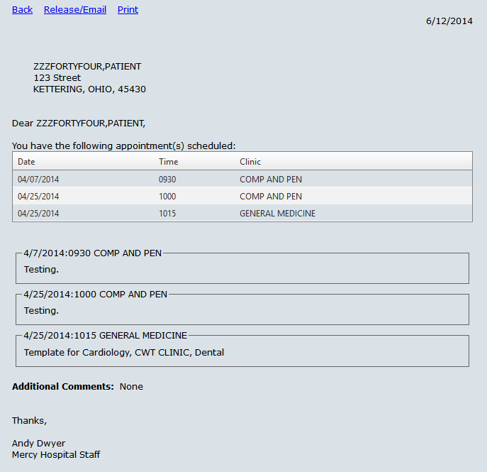

Figure 5: Letter Preview

## Template Management

Only users with the role of ‘Admin’ can access Template Management.

### Template List

* All templates are listed in a table with the following information: (Figure 6)
  + Template ID (link)
  + Message
* Click ‘Download Latest Clinic Information’ to download up-to-date information from the Vista system for the clinics. (Figure 6)

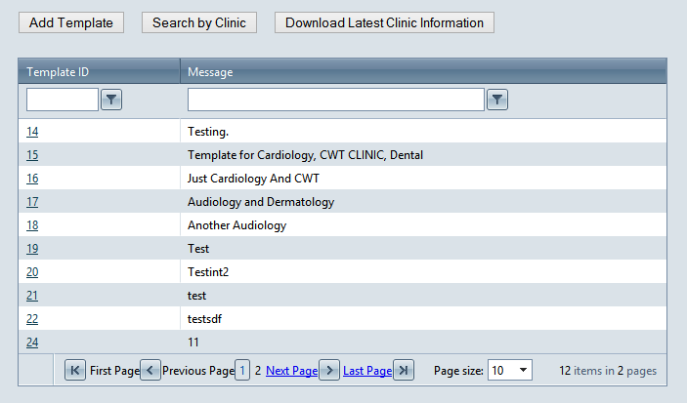

Figure 6: Template List

### Add/Edit Template

* Click the ‘Add Template’ button to create a new template, or click the Template ID of a template to edit it. (Figure 6)
  + The page displays a list of Assigned Clinics and Available Clinics.
* Type the message in the Template Message box. (Figure 7)
  + Click the ‘Preview’ button to view a sample letter using the template.
  + Click ‘Cancel’ to close the Add/Edit form without saving.
  + Click ‘Save’ to save the Template Message.
    - If this is the first time the template has been saved, an alert will pop up that says “The Template has been created.”
* Click ‘Add’ beside an Available Clinic to assign it to the template. (Figure 7)
  + If the template has not been saved, when a clinic is assigned an alert will pop up that says “The Template has been created.”
* Click ‘Remove’ beside an Assigned Clinic to remove it from the ‘Assigned Clinics’ list. (Figure 7)
* Check the ‘Enabled by Default’ checkbox to the right of a clinic to enable the template by default for that clinic. (Figure 7)

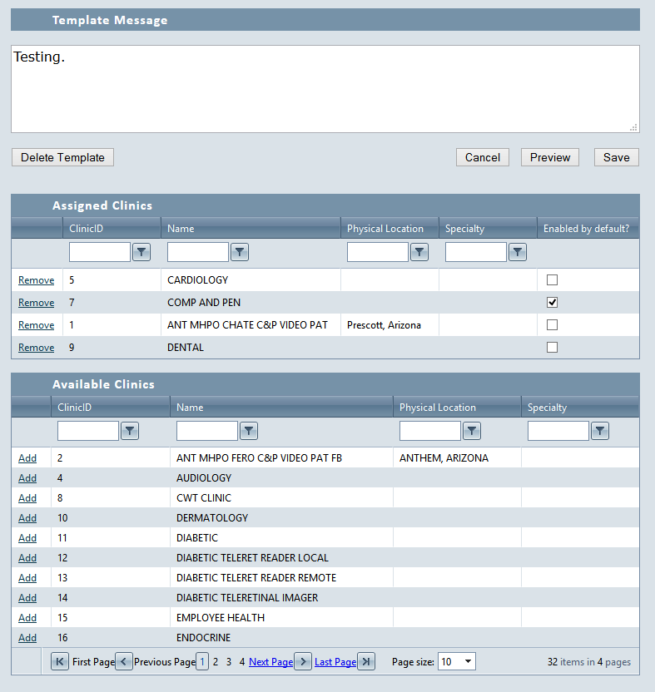

Figure 7: Edit Template

### Delete Template

* Click the ‘Delete Template’ button. (Figure 7)
  + A pop-up message will be displayed asking to confirm the delete.
    - Click ‘OK’.
    - The template is deleted and the Template List is displayed.

### Search by Clinic

* Click the ‘Search by Clinic’ button. (Figure 6)
  + The following tables are displayed:
    - Clinics
    - Assigned Templates
    - Available Templates
* Select a clinic by clicking the row in the grid. (Figure 8)
* Click ‘Add’ beside a template to assign it to the selected clinic. (Figure 8)
  + Click ‘Remove’ beside a template to remove it from the ‘Assigned Templates’ table.
  + Check the ‘Enabled by Default’ checkbox to the right of an Assigned Template to enable the template by default for the selected clinic.
* Click ‘Preview Template’ to view a sample letter using all templates assigned to the selected clinic. (Figure 8)
* Click ‘Search by Template’ to return to the Template List. (Figure 8)
* Click ‘Download Latest Clinic Information’ to download up-to-date information from the Vista system for the clinics. (Figure 8)

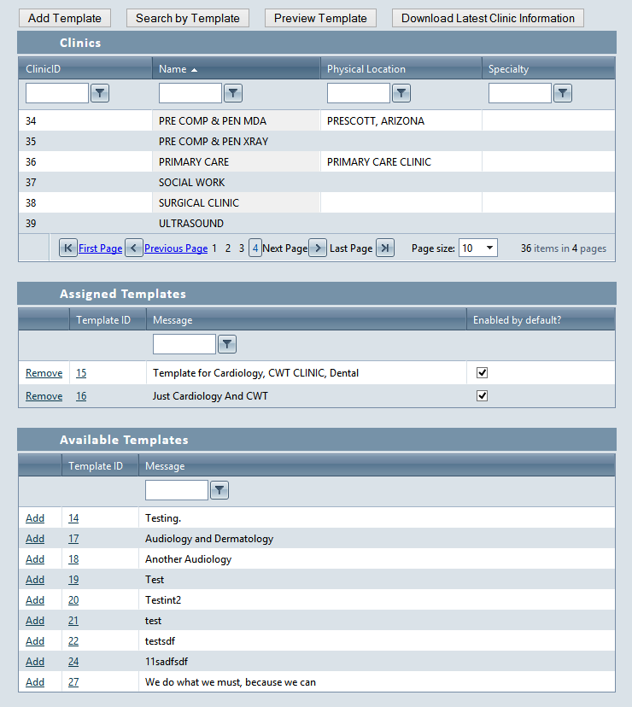

Figure 8: Search by Clinic

## Signature Management

Only users with the role of Admin can access Signature Management.

### Signature List

* Signatures are displayed in a table with the following fields: (Figure 9)
  + Edit (link)
  + Signature ID
  + Title
  + Default (read only checkbox)
  + Delete (link)
* Click the ‘>’ beside a signature to view the signature message nested in the table.

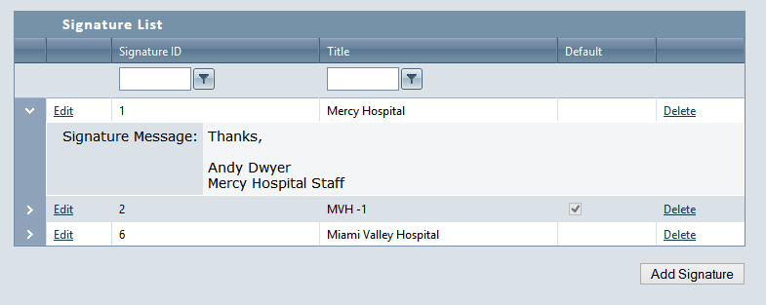

Figure 9: Signature List

### Add/Edit Signature

* Click the ‘Add Signature’ button, or click the ‘Edit’ link on an existing signature. (Figure 9)
* Add or Edit the following information: (Figure 10)
  + Default Signature (Checkbox)
  + Title
  + Signature message
* Click ‘Save’. (Figure 10)
  + If adding a new signature, a pop up message will confirm that the signature has been created.
* Click ‘Cancel’ to exit the Add/Edit form without saving. (Figure 10)

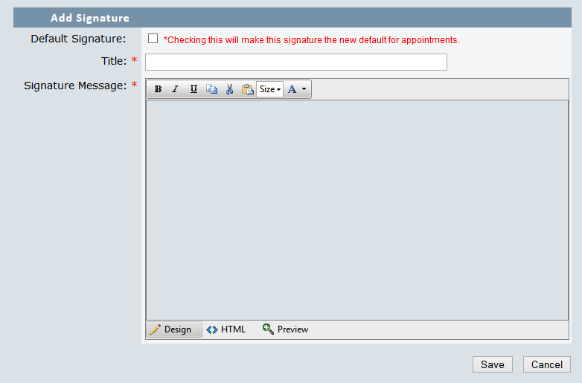

Figure 10: Add/Edit Signature

### Delete a Signature

* Click the ‘Delete’ link next to any existing signature. (Figure 9)
  + The system displays a pop-up message that says “Are you sure you want to delete this signature?”
* Click ‘Ok”.
* The system displays a pop-up confirming the signature is deleted.

## User Information

### Contact Information

* Click the username at the top left of the page to view Contact Information. (Figure 11)
* The system displays the following information:
  + User Name
  + First Name
  + Last Name
  + Email
  + End Date

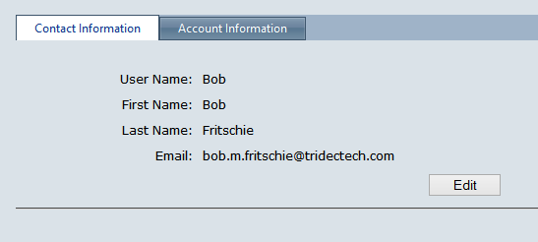

Figure 11: Contact Information

### Edit Contact Information

* Click the ‘Edit’ button below the contact information. (Figure 11)
* Edit the following information: (Figure 12)
  + First Name
  + Last Name
* Click ‘Save’ to save the entered information.
* Click ‘Cancel’ to return to the Contact Information page.

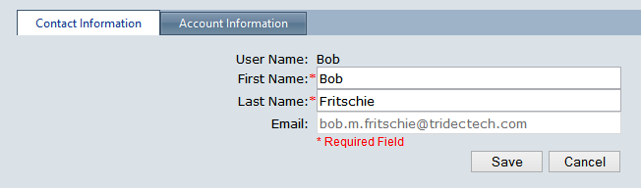

Figure 12: Edit Contact Information

### Account Information

* Click the ‘Account Information’ tab to update account information. (Figure 11)

### Change Password

* To change the account’s password, enter the following: (Figure 13)
  + Password (account’s current password)
    - Passwords must be at least 8 characters, contain both upper and lower case letters, at least one number and one special character.
  + New Password
  + Confirm New Password (must match ‘New Password’ exactly).
* Click ‘Change Password’.
  + A message will be displayed confirming a successful password change.
* Click ‘Cancel’ to clear all password fields.

### Update Security Question

* Enter the following information: (Figure 13)
  + Current Password
  + Security Question (dropdown list)
  + Security Answer
* Click ‘Update Security’.
  + A message will be displayed confirming a successful change.

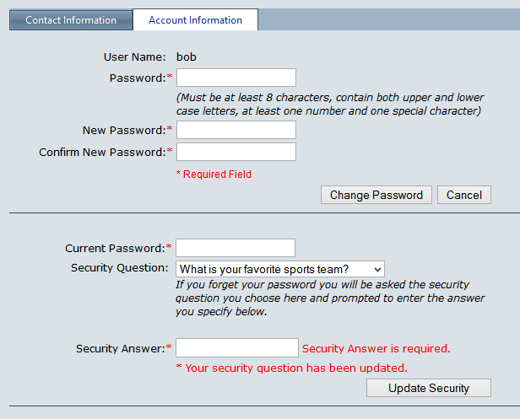

Figure 13: Account Information

## User Management

Only users with the role of Admin can access User Management.

### User Accounts

* The system displays a grid of all users, with the following fields: (Figure 14)
  + Edit (link)
  + View User Access (link)
  + User Name
  + First Name
  + Last Name
  + Email
  + Account Enabled (True/False)
* The table can be filtered in a number of ways:
  + The user can filter the table by:
    - Last Name
    - First Name
    - Email
  + The ‘Clear Filter’ button clears the chosen filter from the table.
  + The ‘Role’ dropdown filters users by role.
  + The ‘Show only Disabled’ checkbox hides all enabled accounts.
* To view a user’s information nested in the table, click the ‘>’ beside that user. (Figure 14)

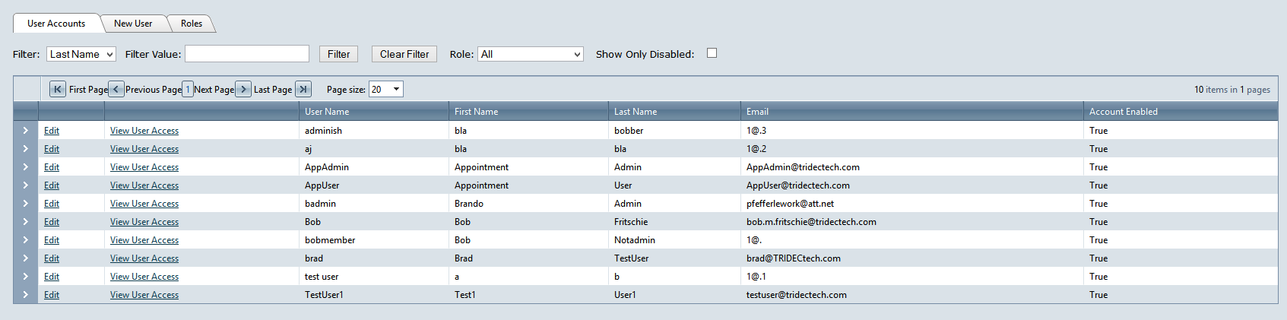

Figure 14: User Accounts

### Edit User Information

* Click the ‘Edit’ link next to a user. (Figure 14)
* Edit the following information: (Figure 15)
  + First Name
  + Last Name
  + Account Locked Out (Yes/No)
  + Account Enabled (Yes/No)
  + Roles (checkboxes)
    - Admin
    - Member (always checked)
    - AppointmentAdmin
    - AppointmentUser
* Click the ‘Update’ button to save changes.
* Click the ‘Cancel’ button to return to User Accounts.

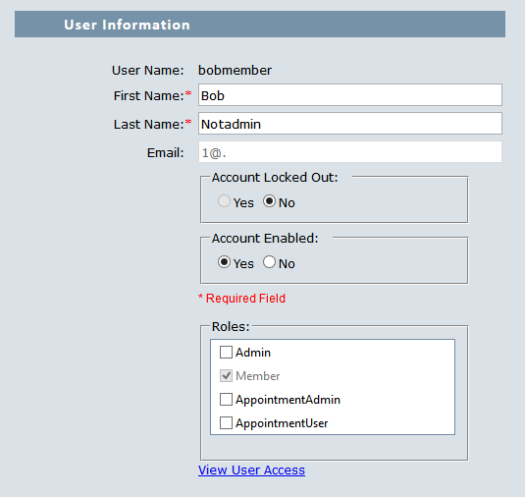

Figure 15: Edit User Information

### Link User to Vista

* If user is already linked to a patient in the Vista system, click ‘Reset Linked User’ to un-link that patient from the selected user. (Figure 16)
* Search for a patient in the Vista system by these criteria: (Figure 17)
  + Social Security Number
  + Name (Lastname,Firstname)
  + Last initial and last four digits of SSN (A1234)
* Click ‘Find’. (Figure 17)
* Click a patient in the grid to link to the user.
* Click ‘Update’ to save changes.

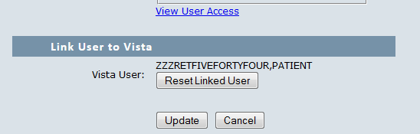

Figure 16: Reset Linked User

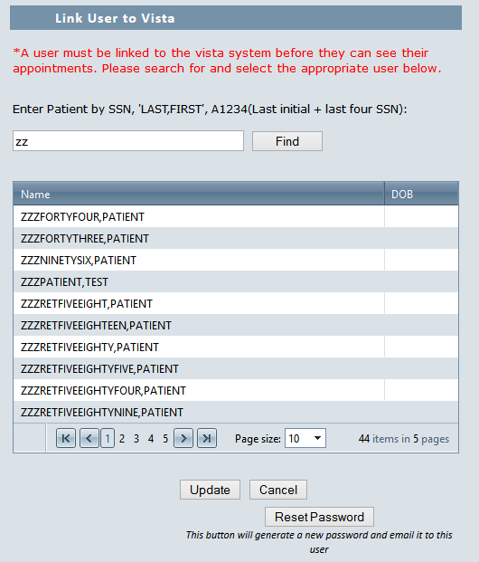

Figure 17: Link to Vista

### Reset Password

* Click the ‘Reset Password’ button to generate a random new password for the user being edited. (Figure 17)
* An Email with the new password will be sent to the user, notifying them of the change.

### View User Access

* The ‘View User Access’ link appears on two pages:
  + The ‘User Accounts’ list. (Figure 14)
  + The ‘Edit User’ form. (Figure 15)
* Clicking the ‘View User Access’ link displays a page with a list of administrative pages that the selected user has access to. (Figure 18)
* Click ‘Return’ to return to the previous page.

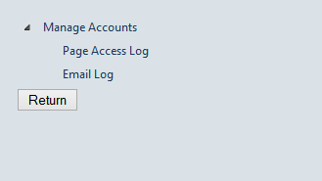

Figure 18: View User Access

### New User

* Click the ‘New User’ tab. (Figure 14)
* Enter the following information (all required): (Figure 19)
  + User Name
  + Password
    - Password must be at least 8 characters, contain both upper and lower case letters, at least one number and one special character.
  + Confirm Password (must match ‘Password’ exactly)
  + E-Mail
  + First Name
  + Last Name
  + Roles (checkboxes)
    - Admin
    - AppointmentAdmin
    - AppointmentUser
    - Member (always checked)
* Click ‘Save New User’ button. (Figure 19)
  + The system displays a pop-up that says “Success.”

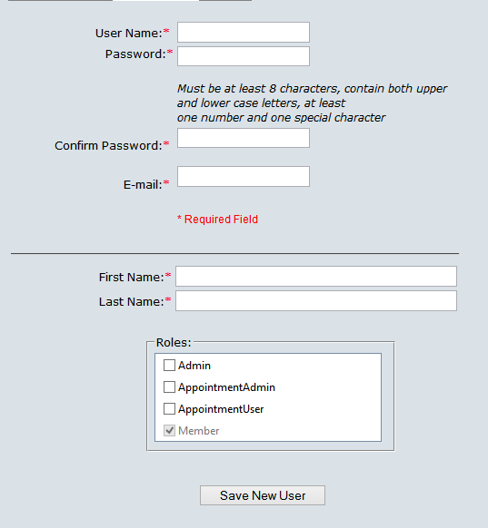

Figure 19: New User

### Roles

* Click the ‘Roles’ tab. (Figure 14)
* A table is displayed with the following information: (Figure 20)
  + Edit (link)
  + View Permissions (link)
  + Role Name
  + User Count
  + Description
  + Delete (button)
* Click the ‘>’ beside a role to view a list of users in that role nested in the table.

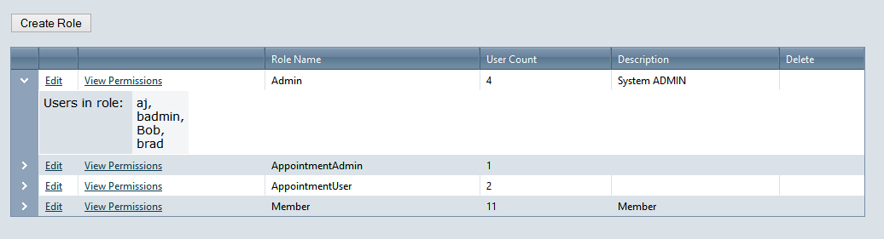

Figure 20: Roles

### Create Role

* Click the ‘Create Role’ button. (Figure 20)
* Enter role information: (Figure 21)
  + Role Name
  + Role Description
* Click ‘Add Role’ button to save role and add to the list. (Figure 21)
* Click ‘Cancel’ button to close the ‘Create Role’ module without saving.

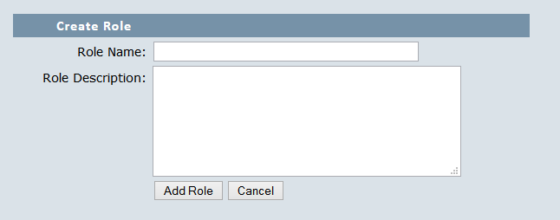

Figure 21: Create Role

### Edit Role

* Click the ‘Edit’ link to load the selected role information into an edit form nested in the table. (Figure 22)
  + Only the role’s Description is editable.
* Click the ‘Update’ link to save changes and close the edit form. (Figure 22)
* Click the ‘Cancel’ link to close the edit form without saving. (Figure 22)

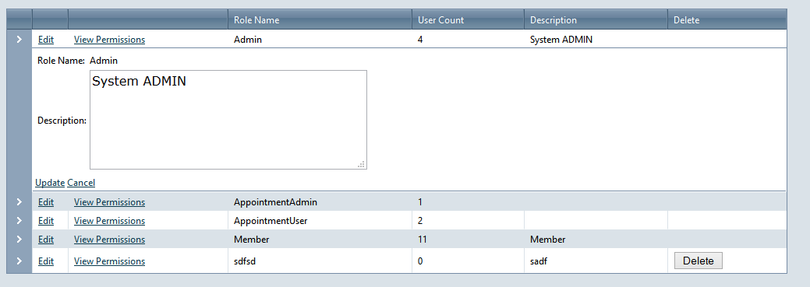

Figure 22: Edit Role

### View Permissions

* Click the ‘View Permissions’ link of a role. (Figure 22)
* The system will display a list of the permissions that role gives users.

### Delete Role

* Click the ‘Delete’ button on a role. (Figure 22)
  + The system displays a pop up message that says “Are you sure?”
* Click ‘Ok’
  + The role is deleted.